**Recommendation to Lana’s Cookies**

Understanding the Customer Demographics

What demographic characteristics are provided in the dataset?

|  |
| --- |
| In this dataset, age group, postcode, gender were collected for the clustering |

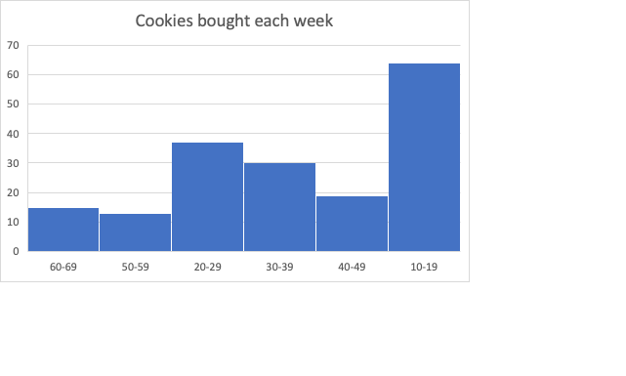

Which demographic group buys the most cookies?

|  |
| --- |
| As shown in the graph above, group 10-19 buys the most cookies. |

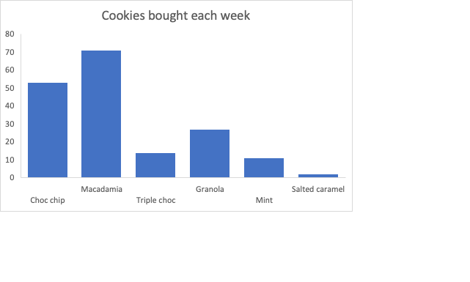

What is the most popular type of cookie?

|  |
| --- |
| As shown in the graph above, macadamia cookie is the most popular type of cookie. |

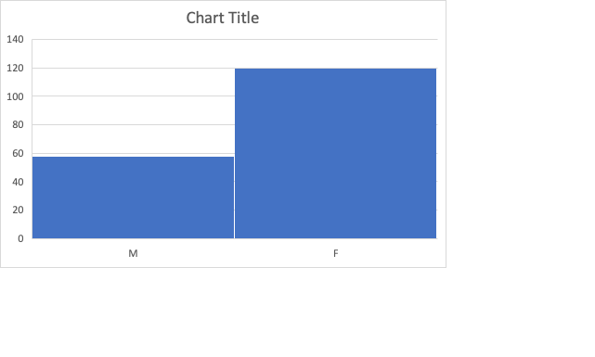

Lana’s Cookie Recommendation

What types of cookie should Lana sell and why?

|  |
| --- |
| Lana should sell macadamia and choc chip cookie because they are the most popular type of cookies. |

Which demographics should she target?

|  |
| --- |
| The age group older than 40 tends not to buy many cookies. Therefore, targeting the age group between 10 to 40 would be ideal. |

Analysis Improvements

How can the data analytics techniques used to provide recommendations to Lana be improved?

|  |
| --- |
| Females buy more cookies than males, so adopting the different strategies of selling for the gender would be proper.  Furthermore, we can do promotions for the less popular cookies like granola and triple choc. |